Domotica and network
Op de Hollandselaan 15
Inhoud
Inhoud 1
Doorbell from Scratch 2
Starting from scratch 2
Connect to Raspberry Pi 2
Via SSH 2
Via VNC 2
Via Filezilla 3
Install LCD screen 3
Record and play sound 3
Play 3
Record 3
Install Python 3.7 4
Install Doorbell’s python script 4
Doorbell’s UserInterface 6
QtDesigner 6
PyQt5 6
Create the default startup routine 7
Hardware 7
Software 8
Camera 8
Intercom to any device at home 8
Call via Ekiga.net 8
Tweeting 8
Streaming from the pi to Bambuser 9
Pi-Hole: My Networkwide Adblocker 9
PI-Hole server settings 9
Raspberry-pi commands and hints&tips 9
Copying an Image or Formatting the sd card 9
Get the audio working 9
Installing the usb-mic 9
Adding an item to the menu 10
http://cagewebdev.com/raspberry-pi-adding-start-menu-items/ 10
Switching between touchscreen and HDMI 10
Information about the OS 10
Information about the computer 10
Playing a sound 10
Wifi-network 10
Devices and their id’s as stated in the ACLlist of the router 10
Mobile Phone with SIP 11
Raspberry Pi calling the landline 11
Vagrant box: Scotchbox 11

Doorbell from scratch

Starting from scratch
Install noobs on the sdcard (see “Copying an Image or Formatting the sd card”), (or raspbian) insert the sd-card into the pi, insert the microphone, insert the speaker, insert the keyboard, insert the mouse and connect the camera and the hdmi to the screen and startup.
If you have no Ethernetcable inserted: Turn on Wifi and connect to your local wifi-network.
On the pi desktop go to menu -> preferences -> configuration: tab interfaces and set to on:
- the camera,
- ssh, so you can connect over ssh
- vnc, so you can connect from any VNC viewr
- spi, i2c for whatever reason.
And reboot your pi.

Connect to Raspberry Pi

Via SSH
Via SSH for a commandline interface to the pi
- ssh pi@192.168.2.103 met ww H..a..!

Via VNC
VNC will connect you to the pi and give you a userinterface, the pi’s desktop.
(After installing realvnc on the pi “sudo apt-get install realvnc-vnc-server realvnc-vnc-viewer” and following the instructions on ‘https://www.raspberrypi.org/documentation/remote-access/vnc/README.md’)
On the pc start the program VNCviewer, enter the pi’s ip-adres that you find by ‘ifconfig’ on the pi’s commandline (for instance 192.168.2.103) and enter user pi and its password (H..a..!)

Via Filezilla
Connect to the pi via sftp to its ip-adres 192.168.2.103 (name it met verbinding genaamd ‘Raspberry’) giving its userid and password (pi and H..a..!)

Install the Kaku-sender
Kaku means Click-On-Click-Off. When the doorbell rings, when someone is at the door ringing our bell, our python-script gets triggered and needs to send a Kaku-signal to the doorbell-chime. For this I took apart the Kaku doorbell-button and connected it to my Pi. Here is how.
Started with this doorbell button 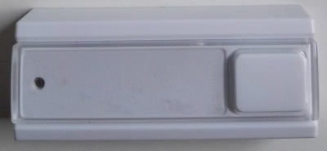
Took it apart and this is the essence of it. 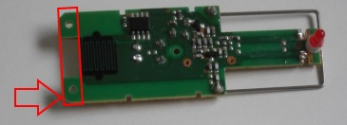
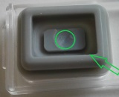
I nibbled of the red-marked bit, to make it fit in the raspberry. Then I cut of the rubber button part that is supposed to press on the black ribbles. I placed it on the black ribbles and kept it in place using a paperclip.
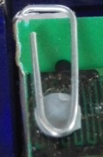
There is no need for the battery, the power comes from the gpio-pins. So I connected wires to the plus and minus of where the battery is supposed to be. Plus going to GPIO-26 and minus going to Ground. Switching on GPIO26 will now trigger the Kaku-sender and thus trigger the doorbell

Next picture you see the nibbled of parts being gone. Also the wrapped backside of the paperclip, which I wrapped in paper to avoid short circuiting other parts. And a good thing that is, because looking at the picture I now see that I pushed heavily against the minus and I am amazed it has not broken nore short-circuited.
Putting the doorbeel in position, wired up and flat, it looks like this.
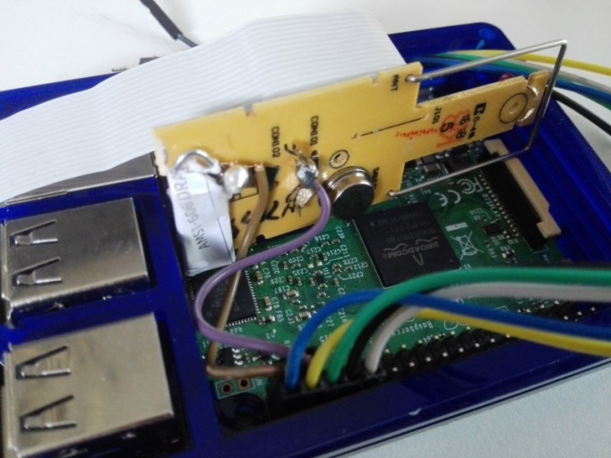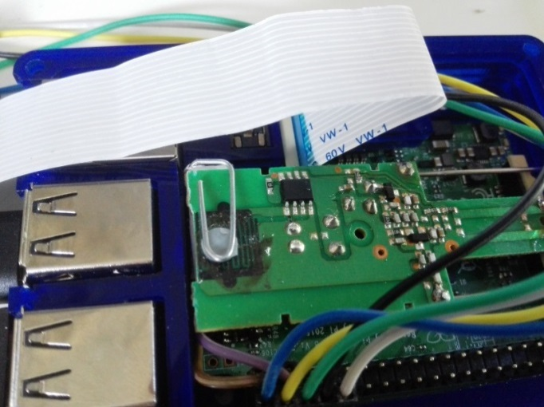

Install LCD screen
I have got the “3.5inch RPi LCD (A) V3 of WaveShare SpotPear”
Set it up conform https://github.com/goodtft/LCD-show. On command-line in the home-directory execute these lines:
sudo rm -rf LCD-show
git clone https://github.com/goodtft/LCD-show.git
chmod -R 755 LCD-show
cd LCD-show2394
/
sudo ./LCD35-show
You can get the screen back to the HDMI output by using: sudo ./LCD-hdmi
The LCD35-show installs package ‘xserver-xorg-input-edev_2.10.5-1’

Switching between touchscreen and HDMI
On commandline give the command: HDMI-SYS-SHOW vs. LCD35-SYS-SHOW. Either one will reboot the pi.

Rotating the commandline to portrait
In /boot/cmdline.txt add
fbtft_device.rotate=90

Rotating the desktop to portrait
In /boot/cmdline.txt add
fbtft_device.rotate=90

Record and play sound
Having both the usb-microphone and the usb-box connected, they show up in the preferences->Audio Control Settings as ‘USB PnP Sound device’ (the mic) and ‘USB2.0 device’ (the box).

Play
Two ways to play a sound: omxplayer and aplay
- ‘omxplayer sounds/example.mp3 –o alsa’ (for ‘–o’: alsa sends sound to the box, local and hdmi don’t) . From python-script call it
- ‘aplay -D plughw:CARD=Device_1,DEV=0 sounds/example.mp3’
‘aplay –l’ will show you the available playback-hardware, in this example: ‘Device_1’
To do so from Python execute it as external command using ‘call’ or ‘os.system’, for example:
os.system('aplay -D plughw:CARD=Device_1,DEV=0 %s' % mp3sound) call(["omxplayer", mp3sound, "-o", "alsa"])

Record
#records for 2 seconds in file demo.wav, with cd quality:
‘arecord demo.wav -D sysdefault:CARD=1 -f cd -d 2’ –f dat
Nice demo by ValentinJ2: http://www.instructables.com/id/Playback-Recorder-With-Raspberry-Pi/
Recording is very soft, how to increase it?

Install Python 3.7 (not really needed and so far the qt-UI for pyqt5 does not function correctly, so skip this)
As described on https://www.scivision.co/compile-install-python-beta-raspberry-pi/:
apt install libffi-dev libbz2-dev liblzma-dev libsqlite3-dev libncurses5-dev libgdbm-dev zlib1g-dev libreadline-dev libssl-dev tk-dev build-essential libncursesw5-dev libc6-dev openssl git
(You can use ‘sudo’ in front of it, but that seems to be less safe and more slow. Does work though.)
wget https://github.com/python/cpython/archive/v3.7.0.zip
unzip the file
cd cpython-3.7*
./configure --prefix=$HOME/.local --enable-optimizations
make -j -l 4
make install
export PATH=$HOME/.local/bin/:$PATH
and check that python3 and pip refer to /.local/bin:
$ which python3 gives: /home/pi/.local/bin//python3
$ which pip3 gives: /home/pi/.local/bin//pip3

Create Doorbell’s UserInterface
The userinterface is created using QtDesigner on a laptop/pc, followed by pyuic5 to convert the Doorbell.ui to DoorbellUserInterface.py and pyrcc5 to convert the resource-file to py

QtDesigner
For creating the userinterface, you can manually create qt-window if you know all the command’s. Better is to create it on your desktop using QtDesigner. You can download it from https://www.qt.io. There is a free opensource LGPLv3 Licensed version. Download, install and have fun designing your personal screen! Worked for me, on my pc.
Create a window in QtDesigner and save it, then use it in a python-script like in /python3_5/qtScreendesign/TemplatePythonWithQt.py

PyQt5, pyuic5 and pyrcc5
On the windows desktop I installed PyQt5 using pip. Look in your python-directory <Python’s dir>/Scripts/, it should contain pip.exe. From commandline run “pip install pyqt5”. This will get you pyuic5.exe and pyrcc5.exe and make these command possible:
pyuic5 <yourqtdesignerfile>.ui > <whatevernameyouwant>.py
pyrcc5 qtScreendesign/qtResource.qrc -o qtScreendesign/qtResource_rc.py

PyQt5
To make python find the PyQt5 modules I had to add these programlines at the top of the code:
import sys
sys.path.append('/usr/lib/python3/dist-packages')

Camera
For a complete manual: http://picamera.readthedocs.io/en/release-1.3/
See ‘TestCameraTimelapse.py’ for a 10-second timelapse script.
For sample time-laps-projects: https://www.raspberrypi.org/blog/timelapse-tutorial-from-carrie-annes-geek-gurl-diaries/. Start a timelapse from commandline:
“raspistill -o image_%04d.jpg -tl 60000 -t 7200000” which takes one image every minute for two hours.
Used also this stop motion and this camera webblogs. And https://github.com/motom001/DoorPi/ from https://www.doorpi.org

Install Video streaming
Until I have found the best and most effective way to do video streaming, I will describe some of the options here.
What are my options: picamera, modules uv4l, imutils, motion, opencv. And also OBS.
Once I have got two camera’s, I will have to take a look at “Create multi-camera motion sensor-controlled surveillance System”

Option 1 picamera
Works for capturing photos. Don’t know yet if you can use it for streaming video.

Option2 uv4l
uv4l seems to be the video-streaming standard in pi-world. Probably the successor of V4L.
This project seems to make video connection available including both video and speech https://www.linux-projects.org/uv4l/. Have not succeeded in getting it to work.

Option 3 OBS
Install OBS on your laptop and have it receive streaming video from the pi-camera

Option 4 Use imutils
Inspired by https://www.pyimagesearch.com/2015/05/25/basic-motion-detection-and-tracking-with-python-and-opencv/
pip install imutils
sudo apt-get install python-opencv
Then copy the motion_detector.py and start it up.
Is giving errormessage “HIGHGUI ERROR:V4L: Could not SYNC to video stream. Device or resource busy”
Option 5 Module motion
sudo apt-get install motion

Streaming from the pi to Bambuser
Only works with a $35 monthly fee to Bambuser.
- Bambuser API-key 3795bf3a4eb8b476c0c186288b432d41, see https://bambuser.com/api/keys
- installation as by http://www.recantha.co.uk/blog/?p=4052
- apt-get update
- apt-get install ffmpeg
- etc, but You do need a Premium-Bambuser-account, a free one won't let you do a live stream.

Streaming to youtube

Install Face tracking
Let’s keep going and install face tracking, later might be usefull for face recognition ☺.
http://www.mindsensors.com/blog/how-to/how-to-install-opencv-on-raspberry-pi-and-do-face-tracking

Transfer files between pi an pc
A single file from pi to pc, invoked from the pc (https://www.raspberrypi.org/documentation/remote-access/ssh/scp.md):
scp pi@raspberrypi:<filename> .

sudo apt-get install filezilla

Install Doorbell’s python script
Installation steps after Noobs is installed and the LCD and other hardware are up and running:
- On commandline: git clone http://www.github.com/timvansteenbergen/doorbell
- Then: sudo apt-get install python-tweepy
Now try and start the Doorbell by going to directory /doorbell and commanding: ‘python startDoorbell.py’ Several times the camera was magically no longer configured to ‘on’, in that case, again go to Menu->Preferences->Raspberry Pi Configuration, switch to tab Interfaces

Adding the doorbell to the autostart
by adding the following lines to /home/pi/.config/autostart/doorbell.desktop:
[Desktop Entry]
Encoding=UTF-8
Type=Application
Name=Doorbell
Comment=This is the Doorbell application
Exec= python /home/pi/doorbell/start.py
StartupNotify=false
Terminal=true
Hidden=false

Making it script call a phonenumber
Started with the raspberrypi doorbell project, an image and manual on this site and the github-source.
Used also this stop motion and this camera webblogs. And https://github.com/motom001/DoorPi/ from https://www.doorpi.org

Left-overs and Todo’s
Todo’s and Features of the internet-connected, intercom-doorbell:
- Create the default startup routine
- Create the READme
- Add several doorbell-sounds and modify the doorbell to any sound you want
- Add Door-open detection
- Add working connection to any mobile phone
- Snapshot gets taken using the camera
- Sending a text to any person of choice XXXXX
- Sending a Tweet to any person of choice
- Muting the indoors music XXXXX
- Dimming the indoors light XXXXX
- Intercom with Sound XXXXX See “Intercom to any device at home”
- Intercom with Sound&Image XXXXX See “Intercom to any device at home”

Create the default startup routine
Conform http://www.mikeslab.net/?p=176, I created a script and did “sudo /etc/init.d/doorbell.sh start”. Did not work.
Added it to crontab with “@reboot /etc/init.d/doorbell.sh start” that did kick of the script, but no doorbell was started.
Added it to /.config/autoload
[Desktop Entry]
Exec=”/etc/init.d/doorbell.sh start”
Type=Application
With no result
The crontab-log did show that the script did start. Just no response was shown at all.

Hardware
- raspberry pi 3B+, https://www.raspberrypi.org/products/model-b/ €35
- micro SD card 8 GB, €7,50
- recordingpart:
- picam, https://www.raspberrypi.org/products/camera-module/ buy here for €30
- microphone, just any usb mic. I used “TRIXES Black Mini Desk Top USB Microphone Speaker” available at amazon.com for 3.99 pounds. Or https://www.sossolutions.nl/3367-mini-usb-microphone for €9
- Klik-Aan-klik-uit Doorbell ACDB 6600AC for €31,-
- communicating to the person at the door:
- LCD-screen:
Either via the first 26 gpio-connectors, 3,5" touchscreen for €26
or via the hdmi-port, 5" touchscreen
- Speaker, https://www.sossolutions.nl/3369-mini-external-usb-stereo-speaker €17,50

Altogether €156,-

And more Raspberry-pi commands and hints&tips
How hot is pi’s cpu (usually 70-80C): vcgencmd measure_temp
Camera
For a complete manual: http://picamera.readthedocs.io/en/release-1.3/
For sample time-laps-projects: https://www.raspberrypi.org/blog/timelapse-tutorial-from-carrie-annes-geek-gurl-diaries/. Start a timelapse from commandline:
“raspistill -o image_%04d.jpg -tl 60000 -t 7200000” which takes one image every minute for two hours.
Raspberry Pi calling the landline
See http://www.raspberry-asterisk.org/
FreePBX https://www.freepbx.org/
Intercom to any device at home
Call via Ekiga.net
Sign up for an account at Ekiga.net: Your SIP address is: sip:timvansteenbergen@ekiga.net met wachwoord Poesa9876!
Install the Ekiga software on your device of choice. Might be your mobile, or your desktop
Install the Twinkle on the Pi: sudo apt-get install python-twinkle
Tweeting
- Install tweepy in the Pi: sudo apt-get install python-tweepy
- Get or create your own Twitter-account
- Create an app on that Twitter-account
- This will get you the customkey, customersecrets, accesskey and accesssecret that you need to enter into tweet.py
- In command Tweet, change the start of variable ‘line’ to your own Twitter-account.

Pi-Hole: My Networkwide Adblocker
See https://pi-hole.net
Installed on any pi with this command:
curl –L https://install.pi-hole.net/ | bash

Copying an Image or Formatting the sd card
Formatting is not necessary when copying a image to the disk. To do this use Win32DiskImager
Using tool SD card Formatter available on https://www.sdcard.org/downloads/formatter_4
Images to copy to the sd-card stored on G:\Documents\raspberry projecten\images
Installing the usb-mic
- Plug in the mic in a usb-port
- sudo apt-get install vim git-core python-dev python-pip bison libasound2-dev libportaudio-dev python-pyaudio –yes
- sudo vim /etc/modprobe.d/alsa-base.conf

Information about the OS
Command “cat /etc/os-release”

Information about the computer
Command “uname” gives the OSname.
With parameters like –o for type of OS. Currently ‘Stretch’. See man uname for other parametervalues.
Temperature of the cpu

Mobile Phone with SIP
To connect my mobile to my landline:
http://android.stackexchange.com/questions/48356/use-my-land-line-with-android#54252
So buy a Gigaset-dx800a-dect and two or three handsets
https://www.bol.com/nl/p/gigaset-dx800a-dect-telefoon-zwart/9005000011398450/

Debugging pythoncode using Python Interactive Debugger 'pdb'
First step is to make the Python interpreter to enter into the debugging mode.
A. From the Command Line
Most straight forward way, running from command line, of python interpreter
$ python -m pdb scriptName.py
> .../pdb_script.py(7)<module>()
-> """
(Pdb)
B. Within the Interpreter
While developing early versions of modules and to experiment it more iteratively.
$ python
Python 2.7 (r27:82508, Jul 3 2010, 21:12:11)
[GCC 4.0.1 (Apple Inc. build 5493)] on darwin
Type "help", "copyright", "credits" or "license" for more information.
>>> import pdb_script
>>> import pdb
>>> pdb.run('pdb_script.MyObj(5).go()')
> <string>(1)<module>()
(Pdb)
C. From Within Your Program
For a big project and long-running module, can start the debugging from inside the program using import pdb and set_trace() like this :
#!/usr/bin/env python
# encoding: utf-8
#

import pdb

class MyObj(object):
count = 5
def __init__(self):
self.count= 9

def go(self):
for i in range(self.count):
pdb.set_trace()
print i
return

if __name__ == '__main__':
MyObj(5).go()
Step-by-Step debugging to go into more internal
- Execute the next statement… with “n” (next)
- Repeating the last debugging command… with ENTER
- Quitting it all… with “q” (quit)
- Printing the value of variables… with “p” (print)
a) p a
- Turning off the (Pdb) prompt… with “c” (continue)
- Seeing where you are… with “l” (list)
- Stepping into subroutines… with “s” (step into)
- Continuing… but just to the end of the current subroutine… with “r” (return)
- Assign a new value
a) !b = "B"
- Set a breakpoint
a) break linenumber
b) break functionname
c) break filename:linenumber
- Temporary breakpoint
a) tbreak linenumber
- Conditional breakpoint
a) break linenumber, condition
Note:**All these commands should be execute from **pdb
For in-depth knowledge, refer:-
https://pymotw.com/2/pdb/
https://pythonconquerstheuniverse.wordpress.com/2009/09/10/debugging-in-python/

